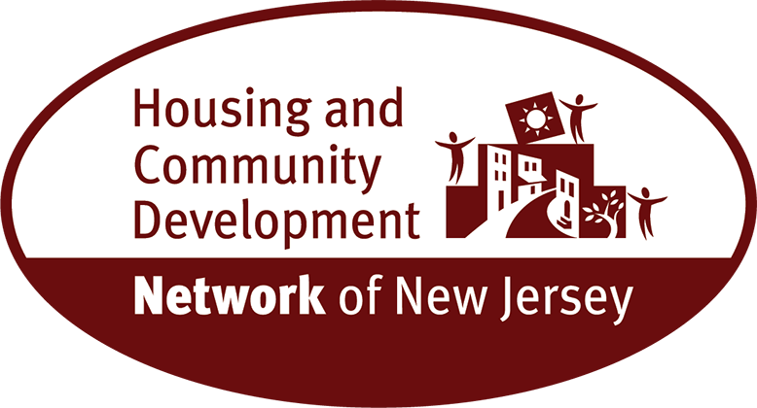
Fact Sheet: Out of Reach New Jersey 2025
- New Jersey is the seventh most expensive location in the U.S. for renters, with only California, Hawaii, Massachusetts, New York, Washington, and the District of Columbia being more expensive.

- In New Jersey, the Fair Market Rent (FMR) for a two-bedroom apartment is $2,079. In order to afford this level of rent and utilities - without paying more than 30% of income on housing - a household must earn $6,931 monthly or $83,173 annually.
- The hourly housing wage in New Jersey for a two-bedroom apartment at FMR is $39.99.
- Among the 34 largest occupations in New Jersey as of 2024, 24 pay median wages less than the 2024 housing wage. 12 of those occupations, accounting for nearly 20% of the workforce, are paid less than half the housing wage. This includes nursing assistants, administrative assistants, home health aides, truck drivers, security guards, janitors, food preparation workers, receptionists, cashiers and others.
- At minimum wage - $15.49 an hour - a New Jersey resident would have to work 103 work hours per week or 2.6 full-time jobs to afford a two-bedroom.

- The average renter wage is $23.97, $16.02 less than the housing wage.
- Hudson County is the most expensive with $2,299 for a two-bedroom rental, followed by Hunterdon, Middlesex, and Somerset counties, all at $2,176.
- Cape May and Gloucester are the least affordable counties with the average renter earning below $12.20 per hour, well under the housing wage.

- 36% of households are renters, with the highest proportions in Hudson and Essex Counties at 69% and 55% respectively.
- New Jersey needs more rental homes across the state that people can afford.
Overall, more than a third of New Jerseyans rent their homes, while the cost to rent a modest two-bedroom apartment is $40 an hour.
For more information, contact: Arnold Cohen, Senior Policy Advisor - Housing and Community Development Network of New Jersey, (609) 393-3752 or acohen@hcdnnj.org

