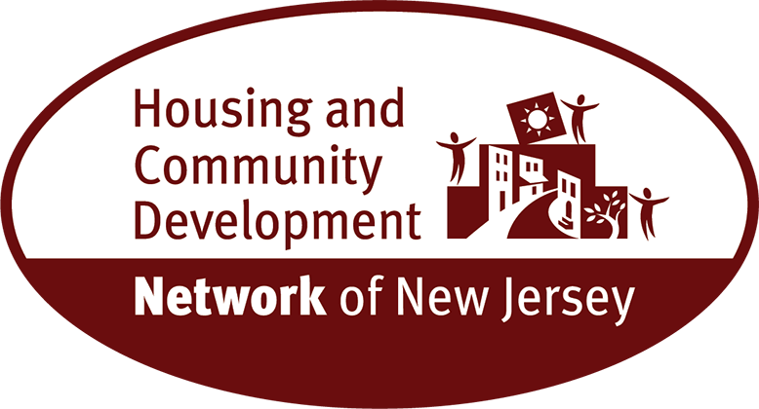
New Jersey Out of Reach - 2024 / 2025

Among the 16 occupations with over 50,000 employees in New Jersey as of 2024, 13 pay median wages less than the 2025 two-bedroom housing wage, and 8 pay wages less than half:

 | Occupation | Total Employment | Jobs per 1,000 jobs | Median Hourly Wage
1 | Cashiers | 93,270 | 21.94 | $16.24
2 | Fast Food and Counter Workers | 86,980 | 20.46 | $16.29
3 | Retail Salespersons | 87,760 | 20.65 | $17.43
4 | Stockers and Order Fillers | 70,780 | 16.65 | $18.00
5 | Home Health and Personal Care Aides | 105,460 | 24.81 | $18.15
6 | Janitors and Cleaners, Except Maids and Housekeeping Cleaners | 67,590 | 15.90 | $18.26
7 | Waiters and Waitresses | 56,560 | 13.31 | $18.95
8 | Laborers and Freight, Stock, and Material Movers, Hand | 101,720 | 23.93 | $19.11
9 | Packers and Packagers, Hand | 76,060 | 17.89 | $20.92
10 | Customer Service Representatives | 64,950 | 15.28 | $22.87
11 | Office Clerks, General | 71,140 | 16.74 | $23.48
12 | Secretaries and Administrative Assistants, Except Legal, Medical, and Executive | 60,320 | 14.19 | $24.27
13 | All Occupations | 4,250,430 | 1000.00 | $28.00
14 | Housing Wage 1 Bedroom |  |  | $33.49
15 | First-Line Supervisors of Office and Administrative Support Workers | 54,460 | 12.81 | $36.08
16 | Housing Wage 2 Bedroom |  |  | $39.99
17 | Registered Nurses | 95,150 | 22.39 | $50.26
18 | Software Developers | 57,120 | 13.44 | $64.78
19 | General and Operations Managers | 63,940 | 15.04 | $73.39
Source: National Low Income Housing Coalition, based on U.S. Bureau of Labor Statistics (BLS). Occupational wages from May 2021 Occupational Employment Statistics, Bureau of Labor Statistics, adjusted to 2022 dollars.
For more information, contact: Arnold Cohen, Senior Policy Advisor - Housing and Community
Development Network of New Jersey, (609) 393-3752 or acohen@hcdnnj.org

